# **Table of Contents**

**Table of Contents** 1

**List of Figures** 2

**1.0 Introduction** 2

**1.1 Social Entrepreneurship** 2

**1.2 Design Thinking** 3

**1.3 Justifications on Design Thinking is a Good Approach to Social Problems** 3

**2.0 Personal Empathy and Connection with Schizophrenia** 4

**2.1 Schizophrenia** 4

**2.2 Impact on Society** 4

**2.3 UN Sustainable Development Goals** 5

**2.4 Personal Strengths and Skills** 5

**3.0 Exploring empathy and creation of insight** 5

**3.1 Users that are impacted by paranoid schizophrenia** 5

**3.1.1 Individuals** 5

**3.1.2 Families** 6

**3.2 Journey Map** 6

**3.3 Customer Profile Map** 7

**3.4 Empathy Maps and Personas** 7

**3.4.1 Empathy Map and Persona of Allie Burke** 7

**3.4.2 Empathy Map and Persona of Cecilia McGough** 8

**3.4.3 Empathy Map and Persona of OML** 8

**4.0 Problem Statement** 8

**5.0 Conclusion** 9

**Appendices** 10

**Appendix 1: Allie Burke** 10

**Appendix 1.1: Journey Map of Allie Burke** 10

**Appendix 1.2: Customer Profile Map of Allie Burke** 11

**Appendix 1.3: Empathy Map of Allie Burke** 11

**Appendix 1.4: Persona of Allie Burke** 12

**Appendix 2: Cecilia McGough** 12

**Appendix 2.1: Empathy Map of Cecilia McGough** 12

**Appendix 2.2: Persona of Cecilia McGough** 13

**Appendix 3: OML** 13

**Appendix 3.1: Empathy Map of OML** 13

**Appendix 3.2: Persona of OML** 14

**List of References** 15

# **List of Figures**

[Figure 1: Schizophrenia 4](https://studentsswinburneedu-my.sharepoint.com/personal/101224694_students_swinburne_edu_my/Documents/BUS/Assignment%201.docx#_Toc51876992)

[Figure 2: K-drama 'It's Okay, That's Love' 5](https://studentsswinburneedu-my.sharepoint.com/personal/101224694_students_swinburne_edu_my/Documents/BUS/Assignment%201.docx#_Toc51876993)

[Figure 3: Stigmatization of mental illness 6](https://studentsswinburneedu-my.sharepoint.com/personal/101224694_students_swinburne_edu_my/Documents/BUS/Assignment%201.docx#_Toc51876994)

# **1.0 Introduction**

The purpose of this report is to discuss social problem through Design Thinking. The first two steps empathize and define will be used to delve deeper about paranoid schizophrenia among young adults who are between 18 and 35 years old and its impacts on the society.

## **1.1 Social Entrepreneurship**

Social entrepreneur is defined as someone who is interested in solving the social needs (Chou 2018, p.73). A social entrepreneur will do entrepreneurial activity or establish a social enterprise as a source of income to sustain and grow his or her organization while at the same time have social impact on the society by addressing and solving the social issues. He or she does not only seek for the pursuits of profits, but he or she also focuses on maximizing the social benefits that the society can gain from his or her innovation (Martin & Osberg 2007).

## **1.2 Design Thinking**

Design thinking is an iterative, fluid and non-linear a way to solve and redefine problems (Ingle 2013). The five steps include empathize, define, ideate, prototype and test. Teams have to first understand the social needs of the society by interacting with the users. After that, teams need to analyze the observations and data that have been collected and create a problem statement. Thus, different solutions are being generated to solve the problem and identify the possible innovative ways to solve the problem statement. Hence, identify the best solutions and start creating prototype. Lastly, test the prototype with real users and collect feedbacks to further improve the product (Sprouts 2017).

## **1.3 Justifications on Design Thinking is a Good Approach to Social Problems**

Design thinking is a good approach to social problems as it involves opinions by real-life users on the prototype instead of the assumptions made by the teams who only create the prototype and are not going to use it in real life (Brown & Wyatt 2010). Hence, the feedbacks that are collected back will be very useful which can help the teams to improve the products that focus on solving the needs of the people. Moreover, this approach allows the teams to repeat the steps in case they have overlooked any problems in the previous steps. This will lead to different creative solutions being generated as it requires people to keep on going back to the steps to understand the problems and identify their new opportunities (Teo n.d.).

# **2.0 Personal Empathy and Connection with Schizophrenia**

## **2.1 Schizophrenia**

Schizophrenia is a mental health disorder which affects a person’s view of reality. Symptoms of schizophrenia includes delusions, hallucinations, disorganized speech, disorganized behaviour and negative symptoms (Mayo Clinic 2020). Five types of schizophrenia include catatonic, paranoid, residual, disorganized or hebephrenic and undifferentiated schizophrenia. People who have delusions and hallucinations are categorized under Paranoid Schizophrenia (Alyssa n.d.). Schizophrenia can be caused by childhood trauma, chemical and structural changes in the brain, genetics, pregnancy complications and previous drug use (Holland 2020). It was reported that there were about 15,104 cases in Malaysia in 2015 (Teoh et al. 2017) and most of them started to have the symptoms when they were between 16 and 25 years old (Schizophrenia and Related Disorders Alliance of America 2020).

Figure 1: Schizophrenia

## **2.2 Impact on Society**

The impact is the financial costs that the society needs to bear with. It has been divided into direct and indirect costs. Direct costs include medication cost, long-term care, publicly owned facility such as mental health hospitals and others. Indirect costs include the decrease in productivity of people who are diagnosed with schizophrenia, their families and caregivers. (Fuller 2016). According to Teoh et al. (2017), the costs of schizophrenia that had to be bear by Malaysia was about USD 100 million in 2015.

Besides that, schizophrenia can cause a lot of problems such as suicide, social isolation, homelessness and others to the society which will disrupt the peacefulness and well-being of the society (Pacific Grove Hospital 2020).

## **2.3 UN Sustainable Development Goals**

In 2015, United Nations Member States had created 17 Sustainable Development Goals to guide all the countries in order to raise the living standards of people in worldwide. Schizophrenia can relate to Goal 3 which is Good Health and Well-being. This goal aims at ensuring people of all age can live in a healthy life and promote their well-being by putting focus on mental health issues (United Nations n.d.).

## **2.4 Personal Strengths and Skills**

I was first notified about this mental issue by a Korean drama called ‘It’s Okay, That’s Love’ where the male lead suffered from paranoid schizophrenia and had hallucinations (Hong 2014). I chose this topic because I know the importance of raising the awareness about this issue and yet it is a taboo topic which we will not often heard of it in Malaysia as people do not want others to associate them as crazy. I want to break the stigma of schizophrenia, so that people are not afraid to share with the public about their stories. I believe my passion of wanting to help people who suffer from this problem will help to raise the awareness by starting to spread related information to people around me.

Figure 2: K-drama 'It's Okay, That's Love'

# **3.0 Exploring empathy and creation of insight**

## **3.1 Users that are impacted by paranoid schizophrenia**

### **3.1.1 Individuals**

Paranoid schizophrenia will affect the quality of life of people as they will hallucinate things which will cause them to feel scared and exhausted. Also, they might lose their source of income as they are not able to work due to having difficulty in interacting with their colleagues and cannot be functional (Disability Benefits Help 2020).

Figure 3: Stigmatization of mental illness

Moreover, individuals will experience discrimination by others which might cause them to have emotional problems. Most of the individuals will have suicide attempts. Stalters (n.d.) stated that there was approximately 20% to 40% of people with schizophrenia had suicide attempts. Studies had showed that a higher number of women had suicide attempts as compared to men and an earlier age onset would also lead to suicide attempts (Aydin et al. 2019).

### **3.1.2 Families**

Family members might have to shoulder the financial burden as they have to pay for the medical fee. According to Teoh et al. (2017), the average cost for each patient was USD 6,594. This high amount of cost is going to cause the family who are of lower income group to feel stressed out as they cannot afford to pay for the fee.

Also, family members would face emotional stress as they have to take care of their family member who is sick and at the same time experience the stigma of the mental illness. ‘Impact on families’ (2019) reported that about 50% of families had experienced high expressed emotion and another 30% of families had experienced emotions such as distress, stressful due to over-involvement, hostility and harsh comments.

## **3.2 Journey Map**

Journey map is a visual presentation that describes how the end users trying to accomplish a task or goal (Service Design Tools n.d.). Appendix 1.1 allows a better understanding of the life of Allie Burke. It also describes about how paranoid schizophrenia has impacted her life, identify what actions will trigger her and how she feels.

I feel sad when she is struggling with her hallucinations and delusions and trying her best to cope with the symptoms in order to live a normal life. However, I also feel proud of her as she knows how to calm herself down when she is not feeling well and seeing her working hard for her goals to help others makes me feel motivated and start to reflect on myself on what can I do to help these people.

## **3.3 Customer Profile Map**

Customer profile map is used to describe a specific target group of customers in order to have a better understanding of their needs and values (‘What is the value proposition canvas?’ 2020). Appendix 1.2 shows the customer’s jobs, gains and pains that they will receive from accomplishing the jobs. Customers should be open minded towards people with schizophrenia. Therefore, patients will not feel lonely and will be willing to open up their heart to share their stories. This can also prevent them from experiencing discrimination from others which will hurt them.

## **3.4 Empathy Maps and Personas**

### **3.4.1 Empathy Map and Persona of Allie Burke**

Appendix 1.3 and 1.4 are the empathy map and persona of Allie Burke. Allie Burke has always been able to see shadows on the wall since she was young which is caused by chemical imbalance in her brain. She has decided to become a mental health advocate to help people who suffer from schizophrenia as she understands the struggles of those people by co-finding Stigma Fighters, a non-profit organization that fights to end the stigmatization of mental illness and help people who are struggling with their mental illness. In this platform, people living with mental illness are able to share their stories (Stigma Fighters 2017). She is frustrated as people constantly use the word ‘schizo’ to describe a person who is insane because it is a disorder, not an insult. People should respect others with schizophrenia as those patients will feel so hurtful and be living in fear of people finding out about their ‘disease’ (Burke 2017).

### **3.4.2 Empathy Map and Persona of Cecilia McGough**

Appendix 2.1 and 2.2 are the empathy map and persona of Cecilia McGough. The chemical imbalance in the brain of Cecilia McGough cause her to see shadows and have psychotic symptoms since she was young. She has founded Students with Psychosis which is a non-profit organization that helps to raise awareness about schizophrenia among college students and empowering students with psychosis worldwide. She feels the need to raise awareness among college students as most of the onset of schizophrenia is around the age of these students. She wants people to stop having negative stigma towards people with schizophrenia (Students with Psychosis 2020).

### **3.4.3 Empathy Map and Persona of OML**

The empathy map and persona of OML are being shown under Appendix 3.1 and 3.2. Her breakup with her tutor was the factor that caused her to have paranoid schizophrenia. She loved him so much that she could not accept how coldly that he had treated her at the end of their marriage. She is devastated as her relationship with her schoolmate, WF also did not go well. After that, she starts to have delusions about WF who is a bad man that has caused her family and her to suffer. Besides that, OML is afraid of the stigma of mental illness because she had granted cautions to keep her identity in secret ((Mohd Shah Mat Esa, Zahiruddin Othman & Mohd Jamil Yaacob 2004, p. 86-89).

# **4.0 Problem Statement**

After using the first two stages of design thinking to do this report, I have a better understanding about paranoid schizophrenia and its impact on young adults that are diagnosed with this issue. From the research, I was able to identify issues that people with schizophrenia are struggling with, not only do they have to struggle to continue to live like a ‘normal’ person, they also need to encounter the stigma by the society and bear with the consequences such as receiving criticisms, being isolated and discriminated by others.

By using the method of design thinking, I was able to come up with a specific problem statement to be able to reflect upon the issues that I had identified throughout the research and relate it back to its impact on the paranoid schizophrenia patients and the society. The question is stated as:

*“How might we raise the awareness among young adults that are aged between 18 to 35 years old and decrease the likelihood of stigmatization towards schizophrenia in Malaysia?”*

This question is being raised as I have identified the similarities between the three personas who are from different countries and different age groups which are, they are diagnosed with the illness in their early twenties and the discrimination by the public. They have met people around them who cannot understand them and leave them after they have opened up about their mental illness. They are frustrated at the public for not being able to understand and view them as a group of “schizo”.

Also, this stigma is even more serious in Malaysia because I have difficulty with looking up for information and interviews that are being done with paranoid schizophrenia patients in Malaysia. There are only statistics being stated as most of the Malaysians are not willing to reveal their identities and expose themselves as they are in fear that the society might be against at them including the persona, OML where only little information regarding to her can be found.

However, Cecilia McGough (cited in Goldman 2020) who has paranoid schizophrenia states that it is worse to hide the illness as nobody knows about the secret and thus, no solutions will be able to come up to help with the issue. Therefore, this question is designed to address these issues.

# **5.0 Conclusion**

In conclusion, I was able to come up with a problem statement that is aimed at addressing the users’ issues as well as their goals and values by using the method of design thinking.

Number of words: 2097 words

# **Appendices**

# **Appendix 1: Allie Burke**

## **Appendix 1.1: Journey Map of Allie Burke**

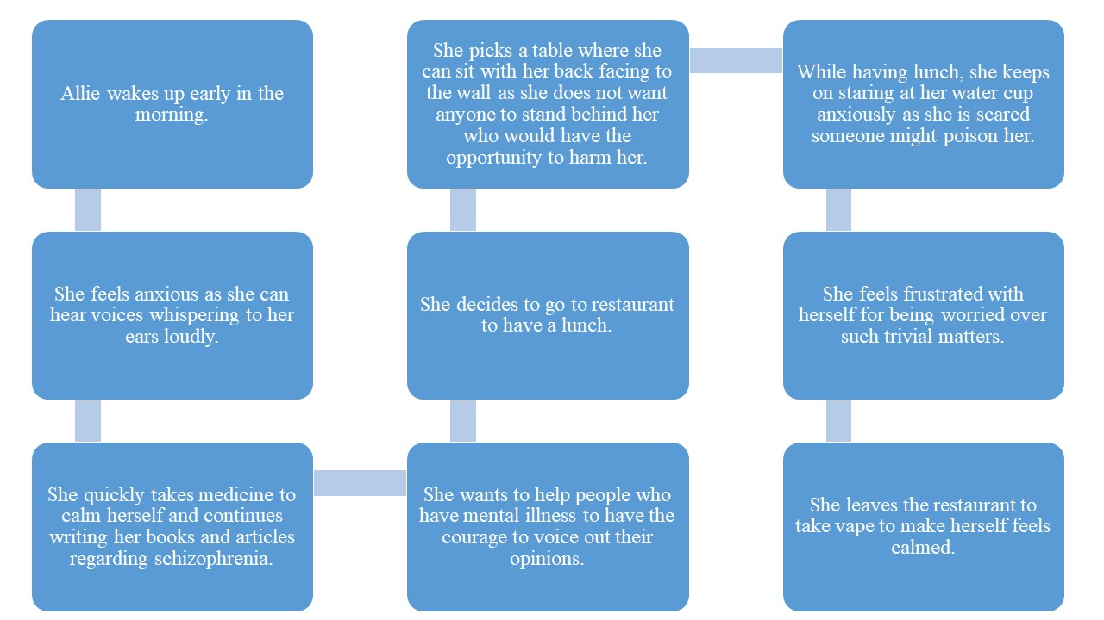

## **Appendix 1.2: Customer Profile Map of Allie Burke**

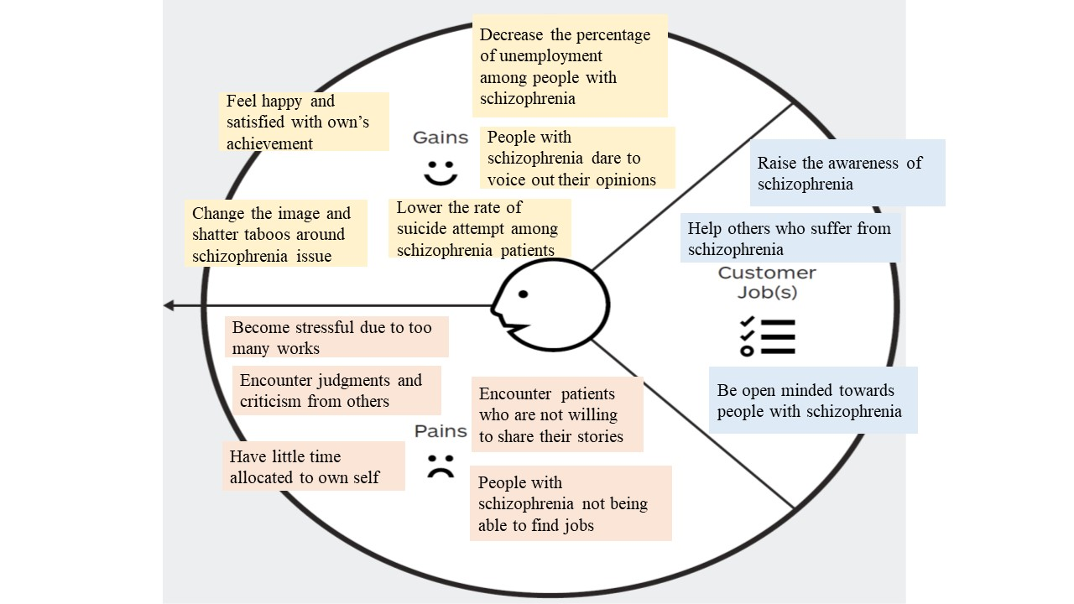

## **Appendix 1.3: Empathy Map of Allie Burke**

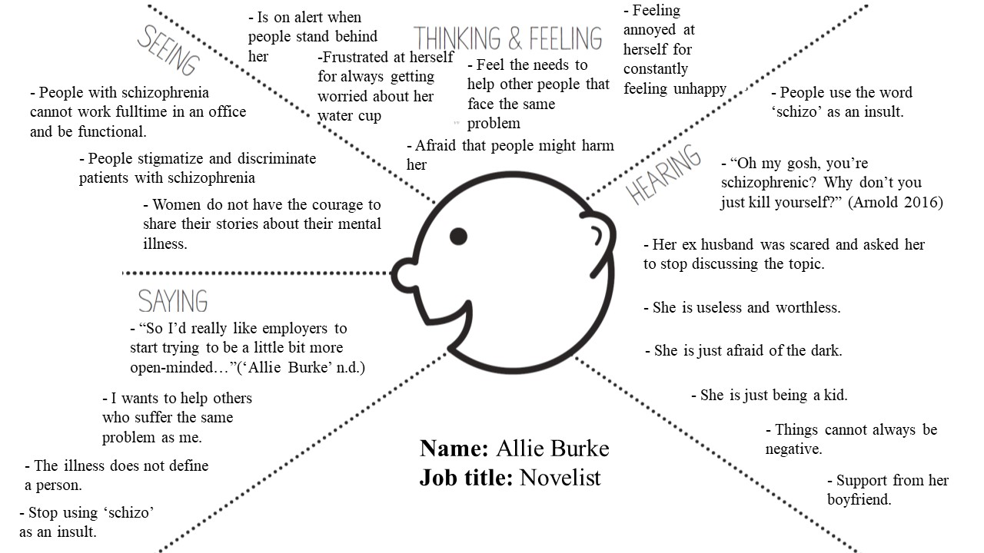

## **Appendix 1.4: Persona of Allie Burke**

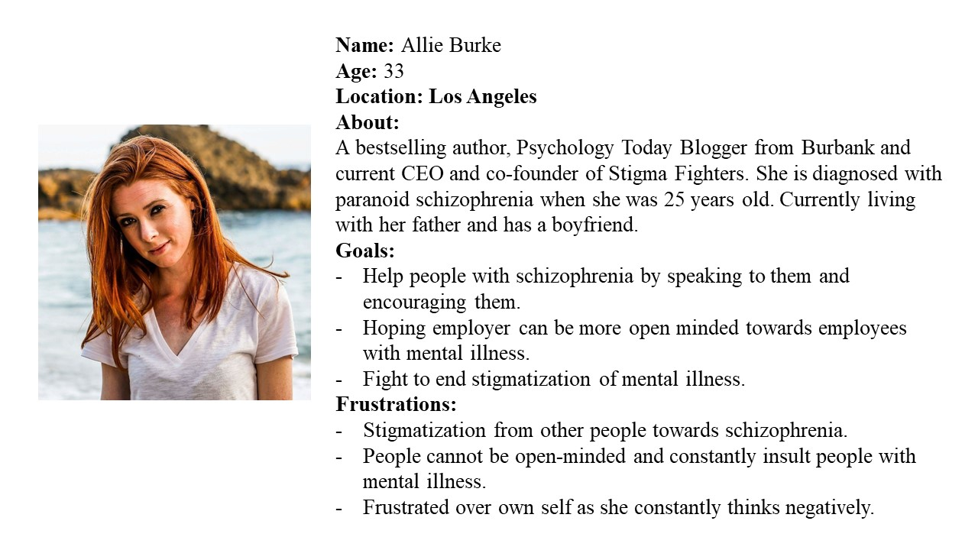

# **Appendix 2: Cecilia McGough**

## **Appendix 2.1: Empathy Map of Cecilia McGough**

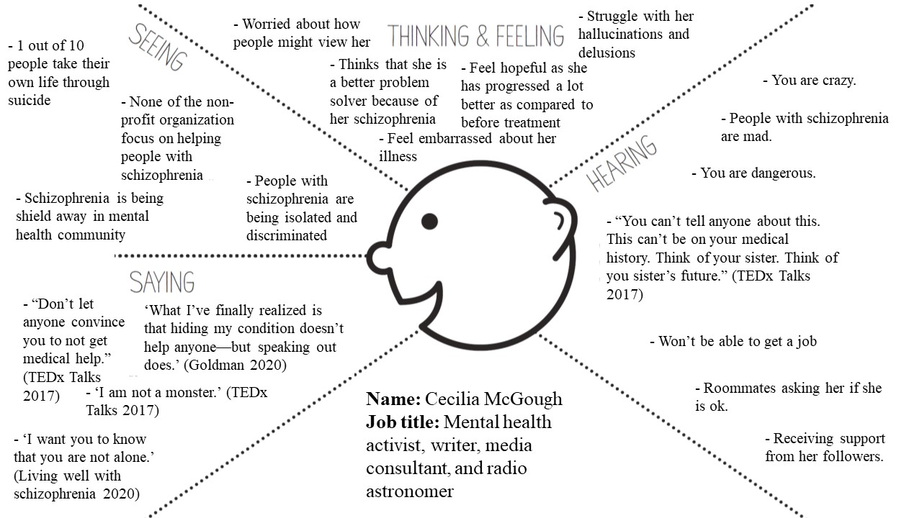

## **Appendix 2.2: Persona of Cecilia McGough**

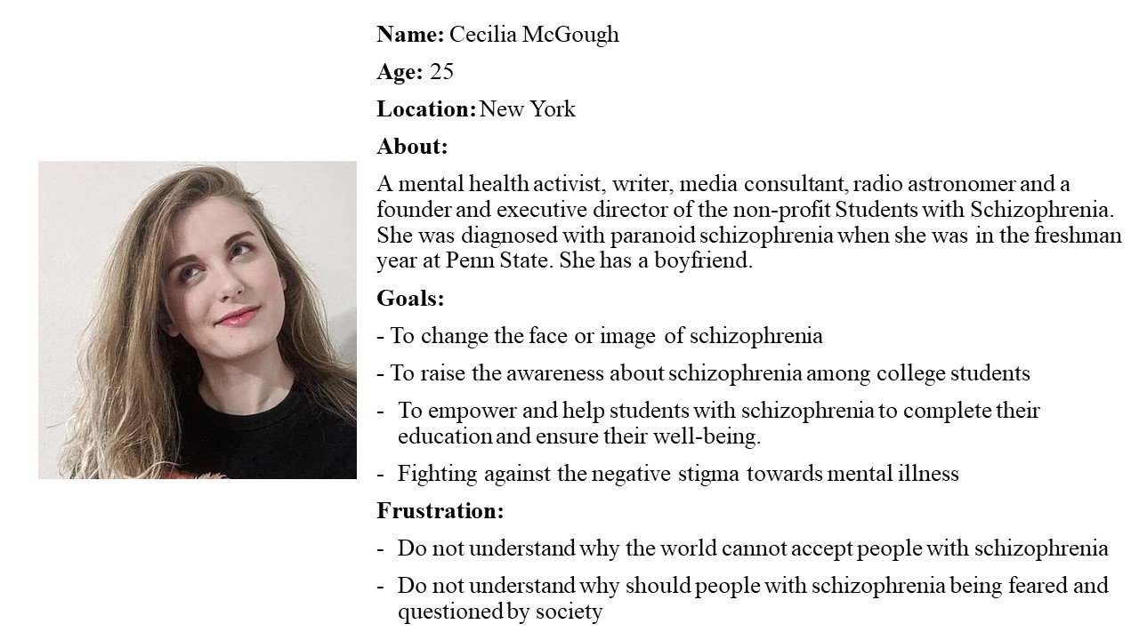

# **Appendix 3: OML**

## **Appendix 3.1: Empathy Map of OML**

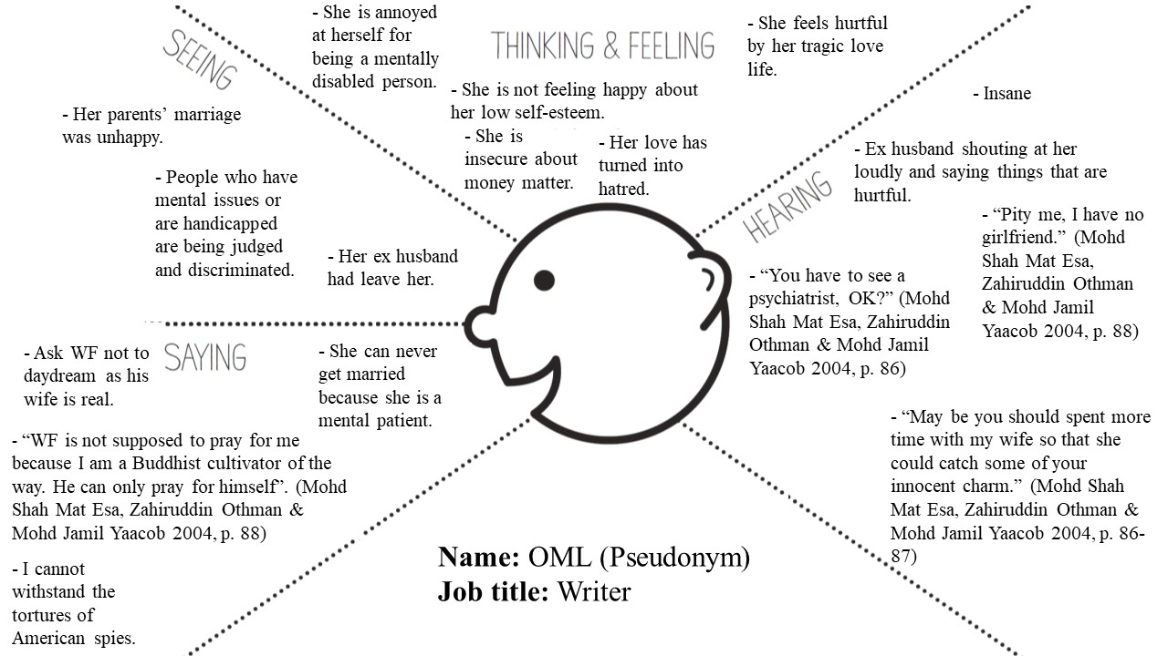

## **Appendix 3.2: Persona of OML**

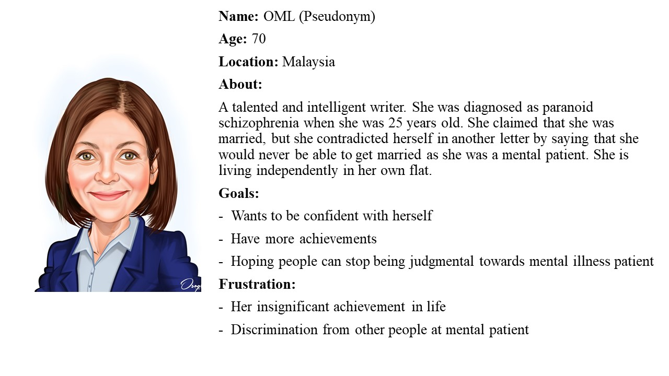

# **List of References**

‘Allie Burke’ n.d., *The Schizophrenia Oral History Project*, viewed 23 September 2020, <https://schizophreniaoralhistories.com/allie/>.

Alyssa n.d., ‘The different types of schizophrenia’, *Banyan Treatment Centers*, viewed 21 September 2020, <https://www.banyantreatmentcenter.com/2020/04/24/different-types-of-schizophrenia/>.

Arnold, C 2016, ‘My schizophrenic hallucinations started when I was 3 years old’, *Women’s Health*, 19 April, viewed 23 September 2020, <https://www.womenshealthmag.com/health/a19949245/allie-burke-schizophrenia/>.

Aydin, M, Ilhan, BC, Tekdemir, R, Cokunlu, Y, Erbasan, V & Altinbas, K 2019, ‘Suicide attempts and related factors in schizophrenia patients’, *Saudi Medical Journal*, vol.40, no.5, pp. 475-482, viewed 22 September 2020, <https://www.ncbi.nlm.nih.gov/pmc/articles/PMC6535170/>.

Brown, T & Wyatt, J 2010, ‘Design thinking for social innovation’, *Stanford Social Innovation Review*, viewed 20 September 2020, <https://ssir.org/articles/entry/design_thinking_for_social_innovation#:~:text=By%20working%20closely%20with%20the,being%20imposed%20from%20the%20top.>.

Burke, A 2017, ‘Please stop using schizo as an insult’, *Psychology Today*, 11 August, viewed 23 September 2020, <https://www.psychologytoday.com/us/blog/paper-souls/201708/please-stop-using-schizo-insult>.

Burke, A 2017, ‘Schizophrenia: living in fear’, *Psychology Today*, 24 January, viewed 23 September 2020, <https://www.psychologytoday.com/us/blog/paper-souls/201801/schizophrenia-living-in-fear>.

Burke, A 2020, ‘To our community from Allie Burke’, *Stigma Fighters*, 19 September, viewed 23 September 2020, <https://stigmafighters.com/to-our-community-from-allie-burke/>.

Chou, DC 2018, *Applying design thinking method to social entrepreneurship project*, Computer Standards & Interfaces, Elsevier ScienceDirect eBooks, pp. 73-79.

Day, C 2019, ‘5 reasons to love “It’s Okay, That’s Love”’, *Chingu To The World*, 1 April, viewed 24 September 2020, <https://chingutotheworld.com/5-reasons-to-love-its-okay-thats-love/>.

Dees, JG 1998, ‘The meaning of social entrepreneurship’, *Kauffman Foundation and Stanford University*, 31 October, viewed 20 September 2020, <https://community-wealth.org/content/meaning-social-entrepreneurship>.

Disability Benefits Help 2020, *Can I continue working with schizophrenia*, Disability Benefits Help, viewed 22 September 2020, <https://www.disability-benefits-help.org/working-ability/schizophrenia>.

Fuller, DA 2016, ‘Research weekly: the high cost of schizophrenia’, *Treatment Advocacy Center*, viewed 22 September 2020, <https://www.treatmentadvocacycenter.org/key-issues/public-service-costs/3599-research-weekly-the-high-cost-of-schizophrenia>.

Goldman, A 2020, ‘Cecilia McGough: I struggle with my schizophrenia out in the open’, *Women’s Health*, 13 February, viewed 23 September 2020, <https://www.womenshealthmag.com/health/a30793602/cecilia-mcgough-schizophrenia-students-with-psychosis/>.

Holland, K 2020, ‘6 causes of schizophrenia that may surprise you’, *Healthline*, 21 February, viewed 22 September 2020, <https://www.healthline.com/health/schizophrenia-causes>.

Hong, GD 2014, ‘Zo In Sung was happy with the viewer reaction to episode 4’s ending’, *CJ E&M enewsWorld*, 6 August, viewed 22 September 2020, <https://web.archive.org/web/20140904170240/http://mwave.interest.me/enewsworld/en/article/72747/zoinsung-talks-about-drama-twist>.

Imhoff, J 2018, ‘Public health forums fight mental health stigma’, *University of Michigan*, 12 June, viewed 24 September 2020, <https://labblog.uofmhealth.org/body-work/public-health-forums-fight-mental-health-stigma>.

‘Impact on families’ 2019, *Neura*, 28 May, viewed 23 September 2020, <https://library.neura.edu.au/schizophrenia/families/impact-on-family/>.

Ingle, BR 2013, Introduction to design thinking, *Design Thinking for Entrepreneurs and Small Businesses*, Apress, Berkeley, CA, Springer, Springer ebooks, pp. 1-15 <https://doiorg.ezproxy.lib.swin.edu.au/10.1007/978-1-4302-6182-7_1>.

Living well with schizophrenia 2020, *A portrait of schizophrenia – Cecilia*, 12 March, viewed 23 September 2020, <https://www.youtube.com/watch?time_continue=200&v=Dk6ZyXIcFyE&feature=emb_title>.

Martin, RL & Osberg, S 2007, ‘Social entrepreneurship: the case for definition’, *Stanford Social Innovation Review*, viewed 20 September 2020, <https://ssir.org/articles/entry/social_entrepreneurship_the_case_for_definition>.

Mayo Clinic 2020, *Schizophrenia*, Mayo Clinic, viewed 21 September 2020, <https://www.mayoclinic.org/diseases-conditions/schizophrenia/symptoms-causes/syc-20354443#:~:text=Schizophrenia%20is%20a%20serious%20mental,with%20schizophrenia%20require%20lifelong%20treatment.>.

Mohd Shah Mat Esa, Zahiruddin Othman & Mohd Jamil Yaacob 2004, ‘Love tragedy, she wrote’, *Malaysian Journal of Medical Sciences*, vol. 11, no.1, pp. 86 – 89, viewed 24 September 2020, <http://journal.usm.my/journal/MJMS-11-1-086.pdf >.

‘Nami: I am not a monster’ 2019, *Carroll College*, 16 September, viewed 23 September 2020, <https://www.carroll.edu/event/nami-i-am-not-monster>.

Negley, K n.d., ‘Part man/ part negative space’, *Pinterest*, viewed 24 September 2020, <https://www.pinterest.com/pin/830140143786585007/>.

Pacific Grove Hospital 2020, *Signs and symptoms of schizophrenia*, Pacific Grove Hospital, viewed 22 September 2020, <https://www.pacificgrovehospital.com/disorders/schizophrenia/symptoms-signs-effects/>.

Schizophrenia and Related Disorders Alliance of America 2020, *About schizophrenia*, Schizophrenia and Related Disorders Alliance of America, viewed 22 September 2020, <https://sardaa.org/resources/about-schizophrenia/#:~:text=Approximately%203.5%20million%20people%20in,is%20at%20least%20partially%20genetic.>.

Service Design Tools n.d., *Journey map*, Service Design Tools, viewed 23 September 2020, <https://servicedesigntools.org/tools/journey-map#:~:text=The%20journey%20map%20is%20a,and%20barriers%20they%20may%20encounter.>.

Sprouts 2017, *The design thinking process*, 23 October, viewed 20 September 2020, <https://www.youtube.com/watch?v=_r0VX-aU_T8>.

Stalters, LW n.d., ‘The truth about schizophrenia’, *Schizophrenia and Related Disorders Alliance of America*, viewed 22 September 2020, <https://www.slideshare.net/SARDAA>.

Stigma Fighters 2017, *About Stigma Fighters*, Stigma Fighters, viewed 23 September 2020, <https://stigmafighters.com/about-stigma-fighters/>.

Students with Psychosis 2020, *Cecilia A. McGough*, Students with Psychosis, viewed 23 September 2020, <https://sws.ngo/cecilia-mcgough/>.

TEDx Talks 2017, *I am not a monster: schizophrenia | Cecilia McGough | TEDxPSU*, 28 March, viewed 23 September 2020, <https://www.youtube.com/watch?v=xbagFzcyNiM&t=108s>.

Teo, YS n.d., ‘Design thinking’, *Interaction Design Foundation*, viewed 20 September 2020, <https://www.interaction-design.org/literature/topics/design-thinking>.

Teoh, SL, Chong, HY, Salina Abdul Aziz, Chemi, N, Abdul Razak Othman, Nurzuriana Md Zaki, Vanichkulpitak, P & Chaiyakunapruk, N 2017, ‘The economic burden of schizophrenia in Malaysia’, *Neuropsychiatric Disease and Treatment*, NCBI, 28 July, viewed 22 September 2020, <https://www.ncbi.nlm.nih.gov/pmc/articles/PMC5546820/>.

Thompson, A 2018, ‘Student with schizophrenia is 'haunted' by horror movie villains: 23-year-old hallucinates daily that she has come face-to-face with the clown from It and the girl from The Ring’, *Daily Mail*, 14 February, viewed 23 September 2020, <https://www.dailymail.co.uk/health/article-5390395/Student-schizophrenia-haunted-movie-villains.html>.

United Nations n.d., *Sustainable development goal 3*, United Nations, viewed 22 September 2020, <https://sdgs.un.org/goals/goal3>.

VICE 2019, *How paranoid schizophrenia impacts my life- a day in the life*, 9 August, viewed 22 September 2020, <https://www.youtube.com/watch?v=5Fpa1X6zT6k>.

‘What is the value proposition canvas?’ 2020, *B2B international*, viewed 23 September 2020, <b2binternational.com/research/methods/faq/what-is-the-value-proposition-canvas/>.